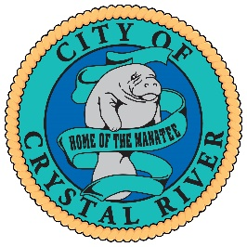

Notice of Planning Commission
Meeting Cancellation
**************************************
The City of Crystal River Planning Commission meeting scheduled for Thursday, August 3, 2023, at 5:30 p.m. in the City Council Chambers located at Crystal River City Hall, 123 NW Highway 19, Crystal River, Florida has been CANCELED.
The Planning Commission will meet at their next regularly scheduled meeting on Thursday, September 7, 2023, at 5:30 p.m. in the City Council Chambers located at Crystal River City Hall, 123 NW Highway 19, Crystal River, Florida

