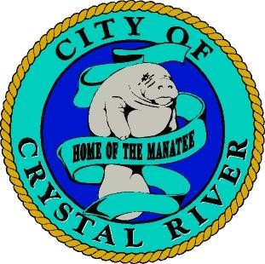
City of Crystal River
123 NW Highway 19
Crystal River, FL 34428
(352) 795-4216 - Phone
(352) 795-6245 - Fax

FACILITIES RENTAL APPLICATION
(4 hours maximum - $25.00)
Reservation Information (352) 795-4216 ext. 314

Name of Individual/Organization: ___________________________________________

Address: __________________________________________________________________

Telephone:_____________________ Email:_____________________________________

Date:___________________ Start Time: _____________End Time:__________________

Event:_____________________________________________________________________

- Little Springs Park – Gazebo ◻ Little Springs Park – Pavilion
(Park Side) (Water Fountain Side) ◻ LeGrone Park ◻ Yeomans Park ◻ Kings Bay Park
(Parking Fees)
Amount Paid:____________Check # _______________Cash______________________

Sorry, facilities at Hunter Springs Park are first come-first serve. All persons using the City of Crystal River recreational facilities do so at their own risk. The City of Crystal River shall have no responsibility for the loss of personal property. NO ALCOHOLIC BEVERAGES PERMITTED.

Signature:_________________________________________________________________

Print Name:_________________________________ Date:_________________________

