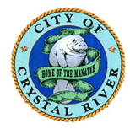

NOTICE:

Please know there are no

Code Enforcement

Hearings being held in

August, 2019.

